Book Proposal

Making Culture a Competitive Advantage:
A New Perspective on the Employee Experience

S. Richard Park, PhD
Tracy L. Platt, MS, GPHR, SPHR
Joseph M. Dunlap, MS

June, 2026

Submitted to


- Contact
S. Richard Park, PhD; rick@talentalignment.net; +1 706.504.2182

- Proposed title and subtitle
Making Culture a Competitive Advantage: A New Perspective on the Employee Experience

- A brief summary of the book
Book Type - PROFESSIONAL

This book is focused on helping executives, managers, professionals, and consultants create a culture that produces a sustainable competitive advantage for a business. It puts forth an innovative “Strategy-to-Culture Value Chain” consisting of elements that influence employee behavior. These elements are:
- Business Strategy – how a business chooses to compete based on customer needs and other environmental factors (competitors, suppliers, etc.)
- “People Systems” configured to produce employee behavior that advances strategy. These are:
  - Selection – including recruiting, promotion, and other scenarios connecting people to jobs
  - Rewards - monetary and non-monetary
  - Structure – job responsibilities and formal/informal communication patterns
  - Performance Management – establishing quality, quantity, and/or time standards for employees.
  - Development – all mechanism intended to advance employee skills
  - Change – the protocols used to introduce new work processes/behavior.
- Culture – workforce behavior considered “normal” by employees.

The figure below captures how the elements of The Strategy-to-Culture Value Chain are connected.

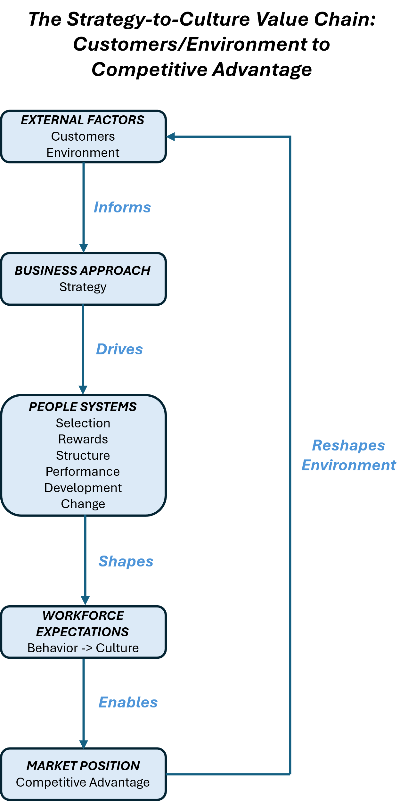

Making Culture a Competitive Advantage dedicates a chapter to each element of the value chain above including:
- evidence-based best practices exploring how to configure each component.
- how to leverage AI to generate processes/content,
- evidence-based best practices, and
- real-world and fictitious examples demonstrating key points.

- Competitive books/How “Making Culture a Competitive Advantage” is different
- Built to Last by Jim Collins & Jerry Porras

- Victory Through Organization by Dave Ulrich, David Kryscynski, Wayne Brockbank, and Mike Ulrich

- The Corporate Culture Survival Guide (3rd Edition) by Edgar Schein and Peter Schein

- Blue Ocean Strategy by Renée Mauborgne and W. Chan Kim

- Competitive Advantage: Creating and Sustaining Superior Performance by Michael Porter

- The Power of Culture by Laura Hamill

- People Strategy: How to Invest in People and Make Culture Your Competitive Advantage by Jack Altman

- Culture Connection: How Developing a Winning Culture Will Give Your Organization a Competitive Advantage by Marty Parker

These books, and others like them, address various components of the Strategy-to-Culture Value Chain we propose in Making Culture a Competitive Advantage. The value chain contained in our book is different for a variety of reasons. Some of the books above address:
- the intersection of market, business environment, and strategy, but do not connect people systems and their potential to embed strategy in employee behavior which, in turn, drives culture.
- people systems, but:
  - do not address the value of explicitly connecting them to strategy,
  - address only a subset of the people systems addressed here,
  - ignore best practices in terms of developing and leveraging them (aka superficial treatment of people systems),
  - are not explicit in terms of the value of connecting people systems through strategy,
  - ignore their potential to creating a culture connected to strategy, and
  - ignore the value of culture in creating a competitive advantage.
- concrete examples demonstrating their principles, but most of these examples feature different organizations – making it difficult to follow how to connect the elements of a specific value chain within a business (see Appendix B).
- how to leverage AI to configure a limited number of people practices, but none offer the breadth offered in this book (annotated AI applications for each element of the Strategy-to-Culture Value Chain.)

- The key features of the book
Making Culture a Competitive Advantage will engage readers in several ways:

An Approachable and Engaging Writing Style – We are dedicated to conveying ideas in a conversational tone. Technical content will be both accurate and understandable. We will feature natural conversations between colleagues where appropriate. See Appendix A for draft content introducing Chapter II – Strategy Doesn’t Have to be Boring! for a sample.

Executive Team Dialogue – Each chapter will end with members of a fictitious executive team working to launch an adjacent retail business. The reader is pulled into the story as the business’ HR Director. The conversations between executives will help make the content in each chapter more concrete and conversational. The executives will occasionally involve experts to reinforce technical content in an easily understood way. See Appendix B for draft content introducing the business, the CEO, and the adjacent business they are launching.

AI Applications – Each chapter will feature guidance on leveraging AI to create/fine tune work processes and content. It will feature instructive commentary crafted by the authors.

Specific and Practical Guidance on Best Practices – Each chapter will not only describe best practices but will also explain how the reader can configure them to maximize their impact and to propagate strategy.

Diversity, Equity and Inclusion – The fictious executive team featured in this book is led by a woman. She is the CEO of a large bakery/grocery supplier called Lauren’s Bagel and Bakery. Dialogue between members of her executive team is respectful and open. Also important to note is the approachable writing style we will use throughout the book.

- Target audience, their needs, and challenges
This book is for executives, managers, professionals, and consultants in any industry who are interested in diagnosing, creating and leveraging organizational culture to establish and defend a valuable market position for a business.

While there are many readers from larger organizations that would benefit, most typically work in/with organizations employing ~100-2,000 employees because:
- managers find it very difficult to accurately interpret and cascade a clear message regarding strategy and culture-consistent behavior to their employees,
- they are unlikely to have robust, strategy-driven people systems in place, and
- they have vastly different ideas regarding what culture is and how to influence it.
The target audience includes:
- Executives, managers, supervisors, professionals and consultants who seek practical guidance on how to configure systems that result in a workforce focused on strategy.
- Entrepreneurs with businesses that would benefit from a formalized strategy and structured people programs that help employees to help the business.
- HR, Talent Management, Organizational Effectiveness and Learning leaders.
- Business leaders who do not have access to experts in HR, Talent Management, Organizational Effectiveness, or Learning leaders.

- Proposed chapter list and summaries

Chapter I
Why Company Culture is a Potential Competitive Advantage
"Culture…is the result of a deliberate effort to create an environment where people can do their best work. When you have that, you have a competitive advantage that no one can easily replicate.”
Frances Hesselbein, former Editor-in-Chief of Leader to Leader

“Company Culture” is a powerful driver of employee behavior. As such, it has the potential to focus employees on creating a competitive advantage for their organizations, impeding progress in the context of company strategy, or producing results somewhere in between. This chapter clarifies what culture is and its potential impact on a company’s desired position in its chosen markets.

The figure below represents the interplay between a business’ environment and various organizational characteristics. In particular,
- The environmental factors executives consider as they establish direction for their business.
- Three interdependent layers describing business direction with increasing levels of specificity:
  - Mission – “Why” an organization exists.
  - Vision – A concrete and compelling description of the future.
  - Strategy – What the organization intends to do to accomplish its vision.
- What employees expect from each other. Employee expectations can be represented on a continuum anchored by:
  - Strategy – a focus on the business’ direction, and
  - People – an emphasis on employee needs.

A Framework Connecting a) an Organization’s Business Environment to b) the Behavioral Choices Made by Employees

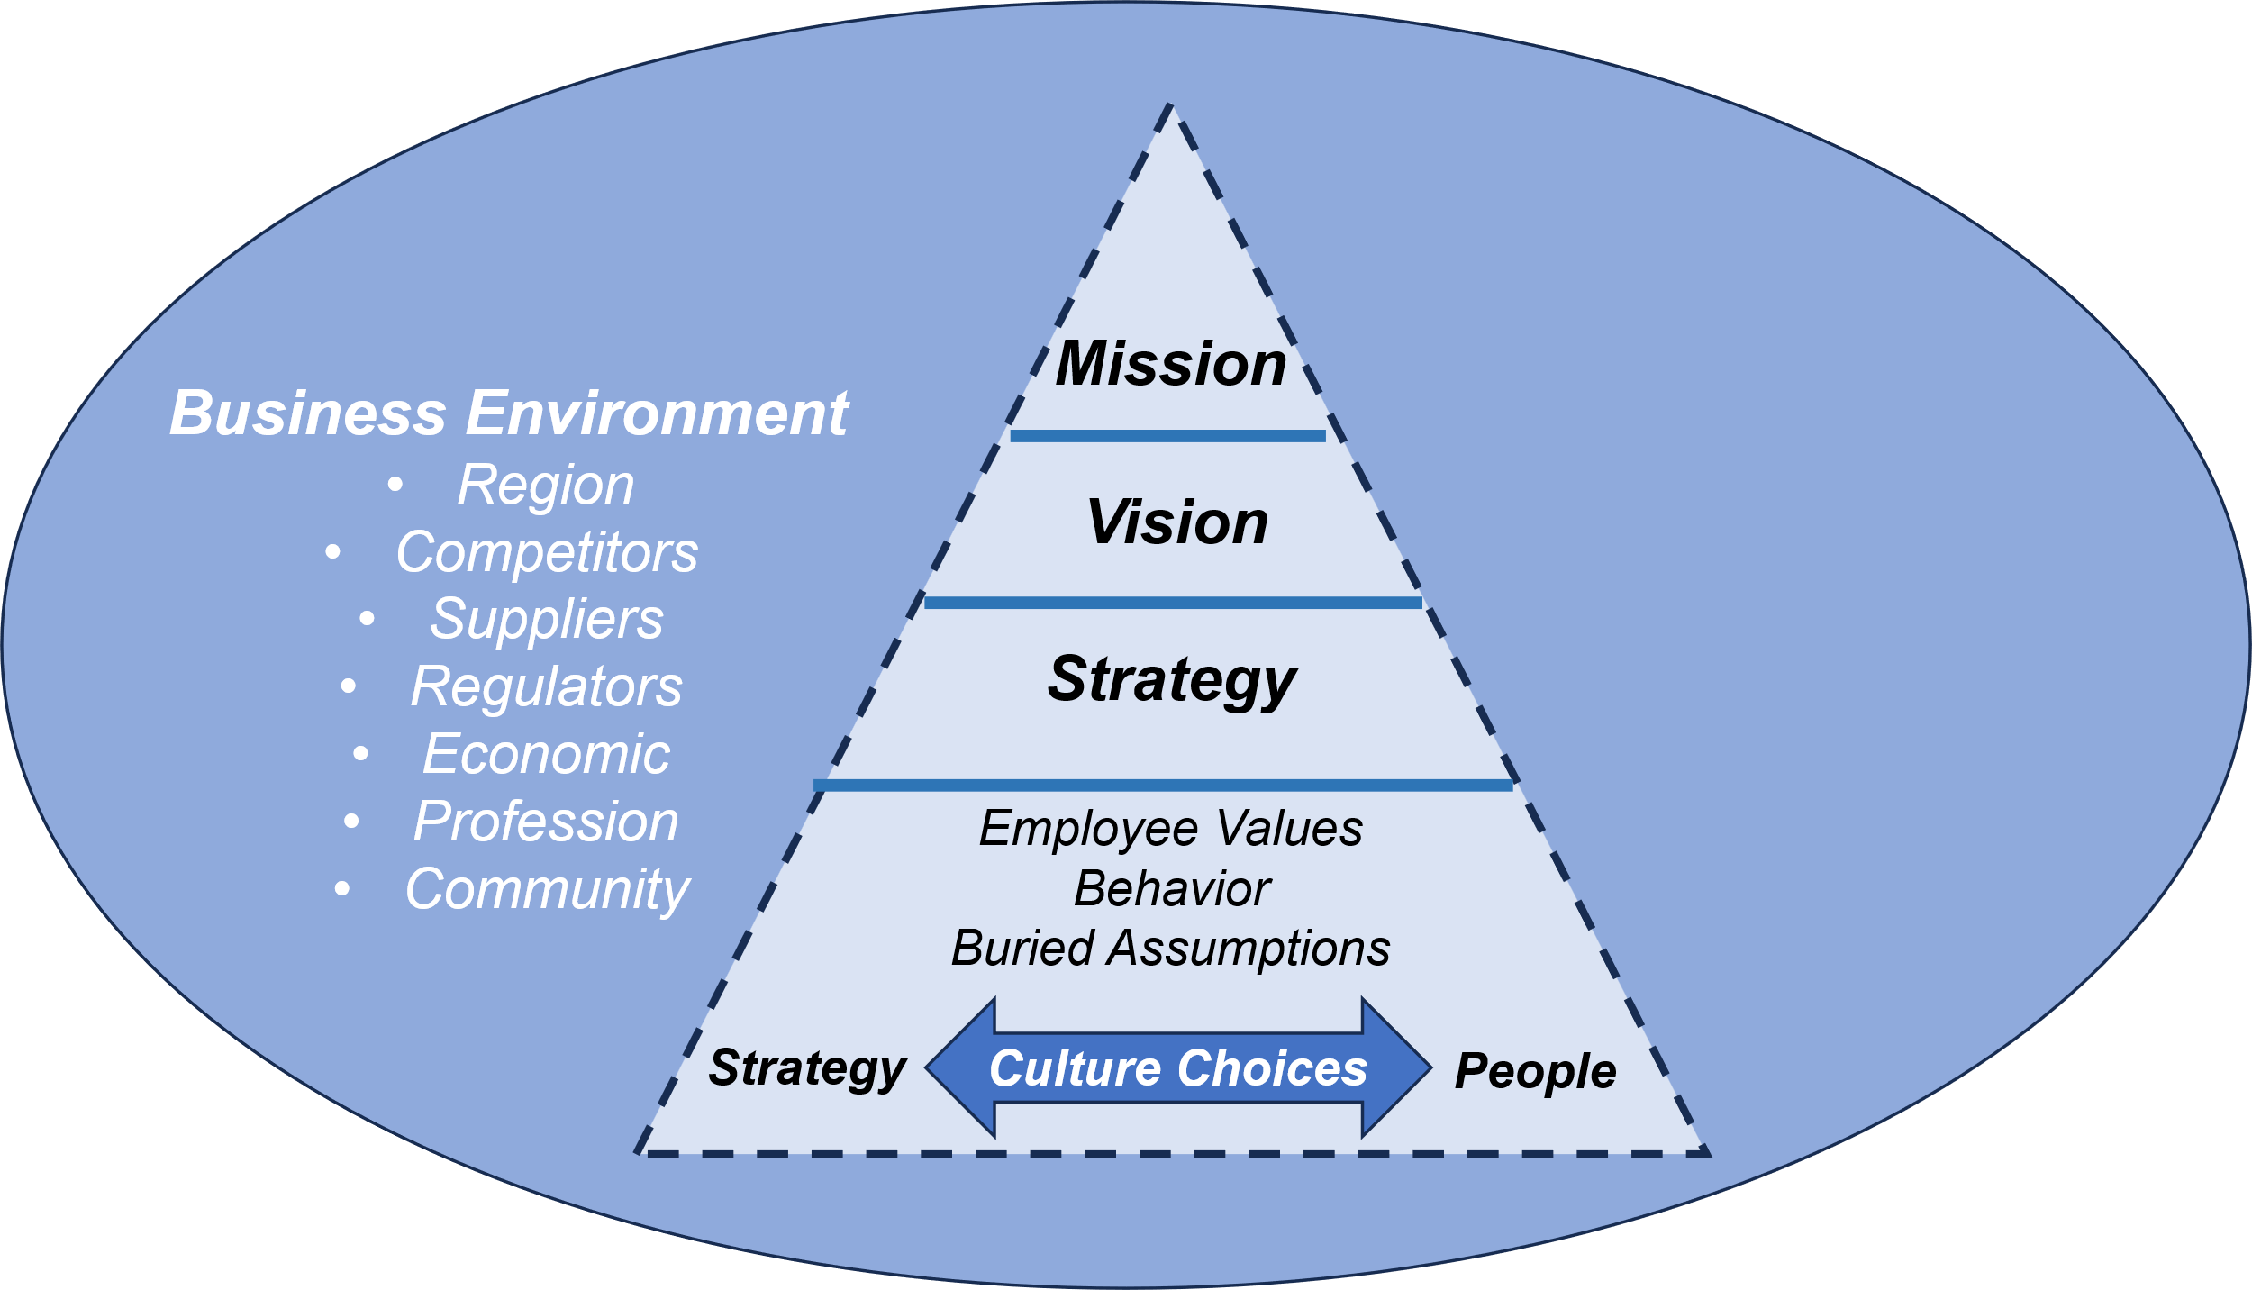

Chapter II
Strategy Doesn’t Have to be Boring!
“Strategy is about making choices, trade-offs; it's about deliberately choosing to be different.”
Michael Porter – Harvard Business School
This chapter grounds the reader in critical organizational features that define how a business chooses to compete within its chosen market. It introduces Mission, Vision, Strategy, Operational Planning and the role they play in a business’ performance.
Subsequent chapters are intended to describe how various organizational processes/features can influence employee behavior to advance strategy.
Important note - While the remaining chapters address relatively independent processes, anchoring each in strategy creates alignment between them while sending a consistent message to the workforce.

Chapter III
Strategy’s Crystal Ball:
Selecting and Promoting Candidates
“People are not your most important asset. The right people are.”
Jim Collins
Ideally, executives and managers decide how to structure work to reflect activities that advance strategy. Selection and promotion advance strategy by identifying the candidate best positioned to create a competitive advantage for the business given the activities associated with the organization’s roles.
The figure below will be leveraged to describe how job-relevant selection and promotion procedures are established. It is derived from legal guidelines (EEOC) and professional standards (American Psychological Association & Society for Industrial and Organizational Psychology).
A Framework Depicting Legal and Professional Standards in Selection/Promotion*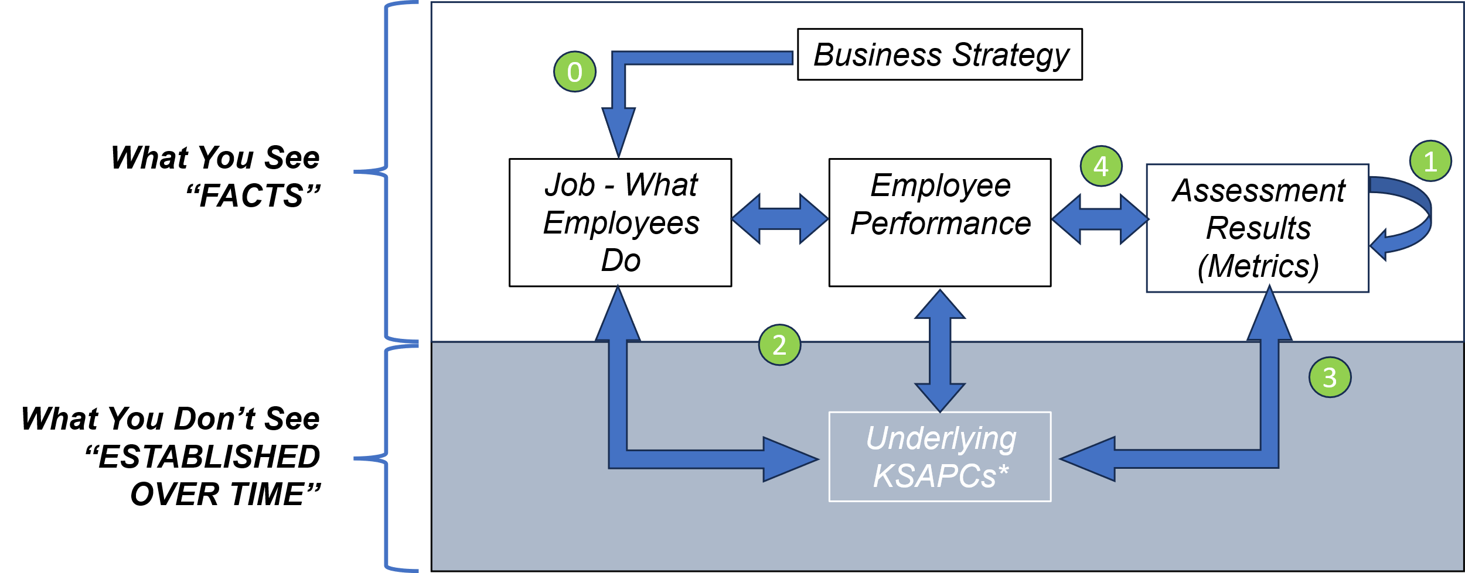
*Knowledge, Skills, Abilities, and Personal Characteristics

Chapter IV
Beyond the Paystub:
Creating Business Value with Rewards
“To stay ahead, companies must provide the rewards and recognition that make it worthwhile for people to innovate.”
Rosabeth Moss Cantor – Harvard Business School
Monetary and non-monetary rewards should be configured to reflect a business’ strategy. Doing so reinforces employee behavior that creates a competitive advantage and signals “what is right” to an organization’s workforce.
Rewards practices rely on a rewards philosophy to connect them to strategy. This is a formal statement documenting the company’s position about employee rewards. It explains the ‘why’ behind employee rewards and creates a framework for consistency.

Rewards philosophies often address issues like:
- Strategy and targeted customer market(s)
- Retention assumptions
- Benefits:
  - Financial
  - Health/Wellness
  - Perks
- Individual/Organizational performance
- Equity and risk tolerance
Don’t forget about non-monetary rewards like unexpected time off, flexible hours/locations, discounts, transit/parking, occasional praise, etc.
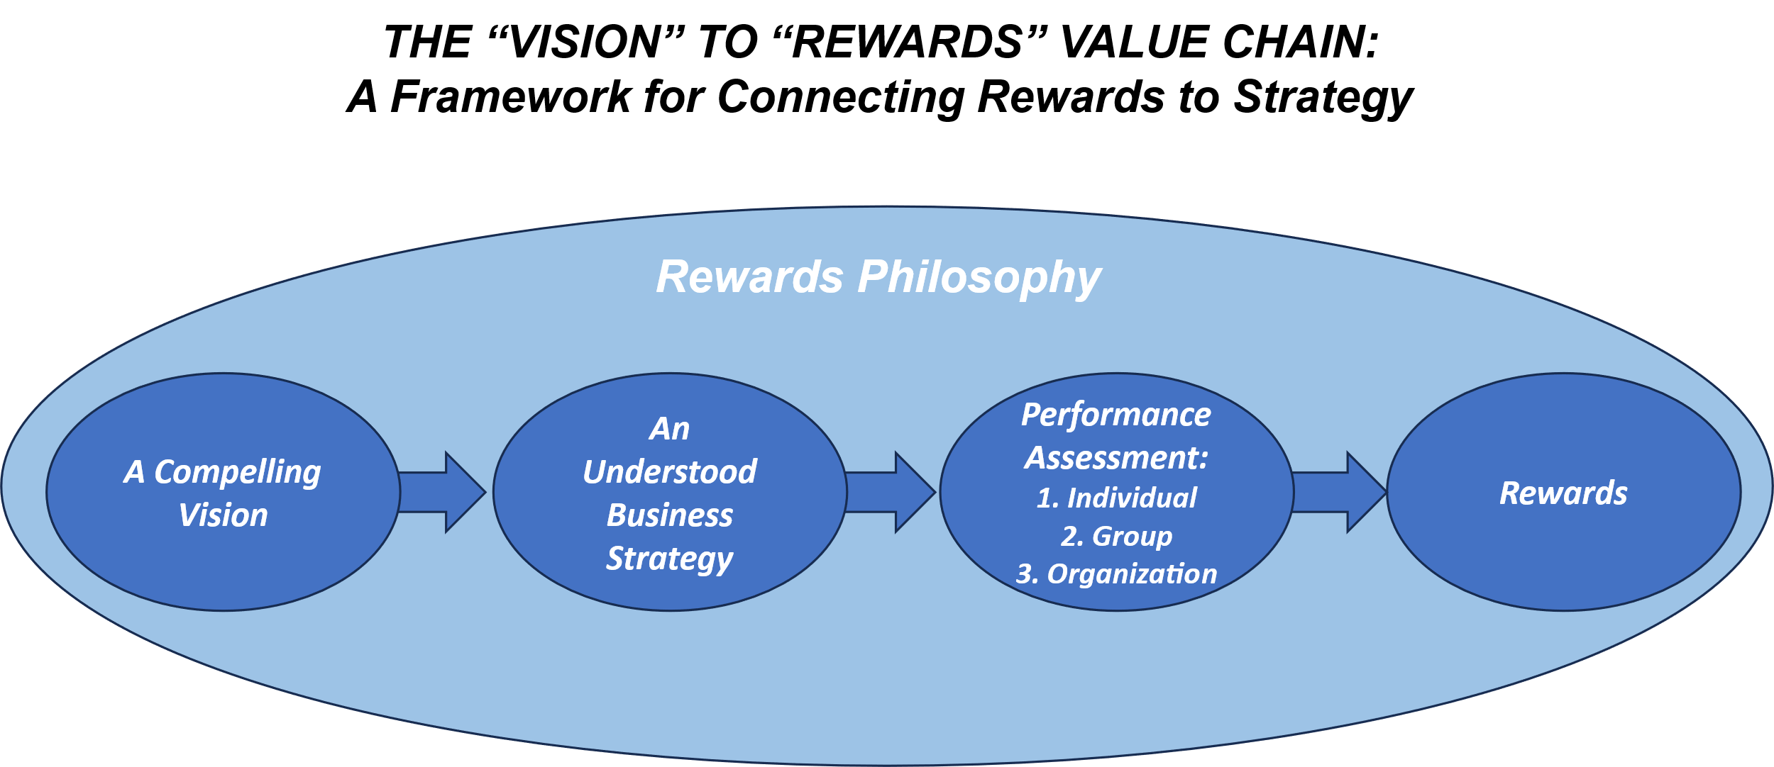

Chapter V
Separating Truth from Noise:
The Essence of Performance Management:
“Performance management that builds employee capability and accountability is the engine of organizational performance.”
Dave Ulrich

Processes used to guide employee performance vary widely across organizations. Executives and managers make choices regarding intent, content, structure, breadth, timing, feedback intervals, scaling, business changes, and a myriad of other factors typically associated with performance management. In this chapter, we leverage research in employee motivation and development to help employees create a competitive advantage for their business.

Strategy should fuel performance management through its two components:
- “The What” – Employee goals, responsibilities, and expected results.
- “The How” – Knowledge, Skills, Abilities, and Personal Characteristics (KSAPCs). These are the employee capabilities required to deliver results and are useful in diagnosing performance deficits.

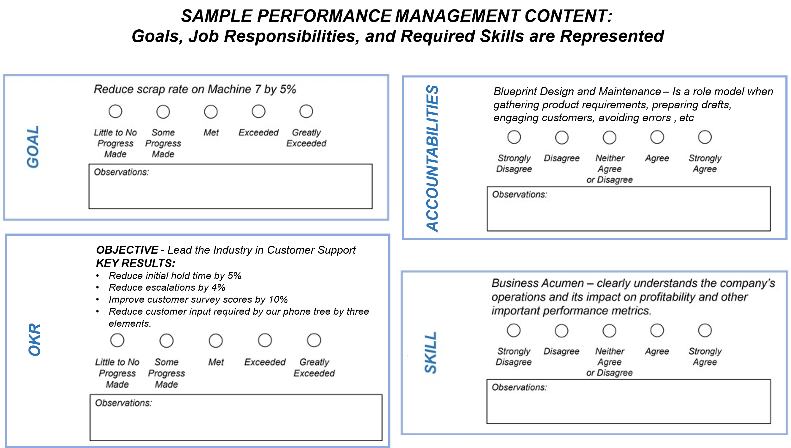

This chapter will also address various factors that impact the quality of the dialogue between a manager and their employee. These include scaling, cadence, opportunity to observe, weighting, calibration, and others.

Chapter VI
Developing Employees to Win Your Markets:
It’s More Than Just Training
“If you don't develop your people, you don't grow your company.”
Satya Nadella – Microsoft CEO

“MIND THE GAP” is a phrase that reminds London commuters to pay attention to the space between the train and the platform.

“MIND DEVELOPMENT GAPS” is far more complex.
Development gaps are evident when:
- Performance standards are unmet.
- Employees transition to new roles.
- Strategy changes.
- Successors are considered.

The figure below offers a framework in identifying the root cause of employee performance challenges be they contextual factors or worker capabilities.

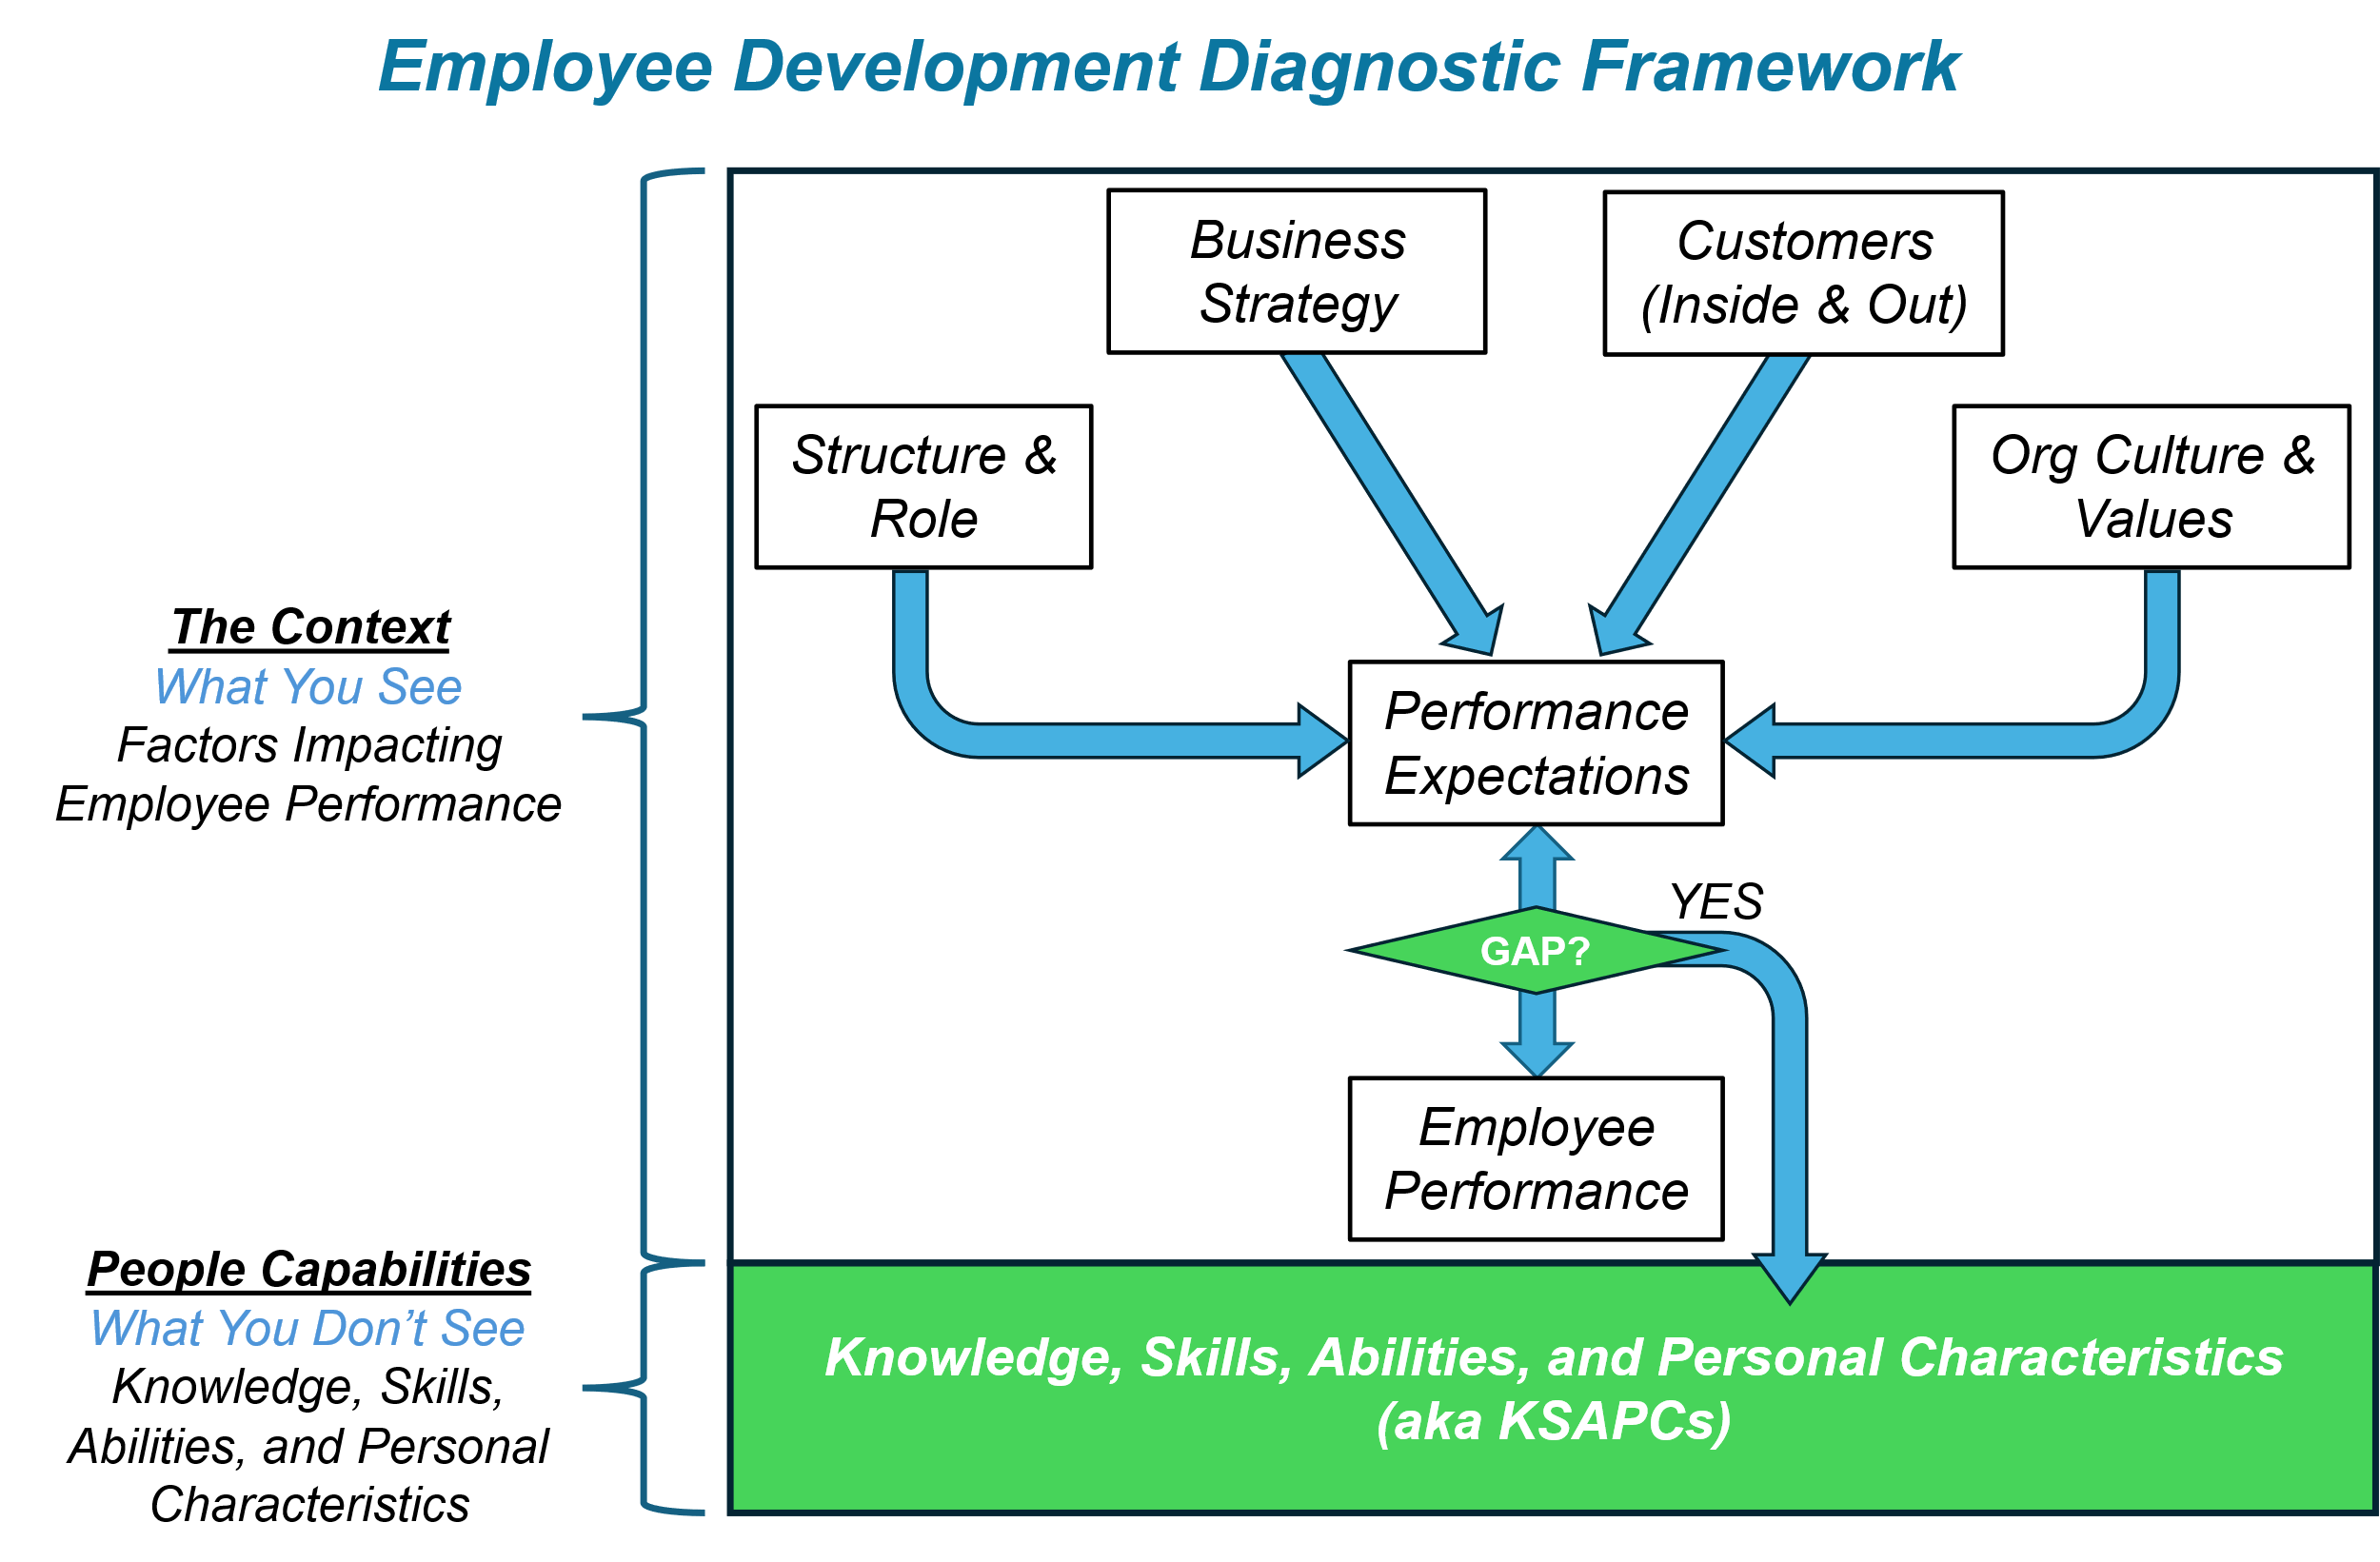

Finding “the right” development activity to narrow performance gaps is an exercise in creativity. Here are just a few development solutions to get you started:
- Reading
- Video
- Coaching
- Mentoring
- Special projects
- Volunteer assignments
- Job shadowing

Chapter VII
Structure Isn’t Organizational Design…and Why You Should Care
“Effective organizations achieve consistency between structure and strategy. Misalignment between the two undermines performance and weakens competitive position.”
Henry Mintzberg

Imagine working for a company that has established a competitive advantage in next-day delivery. Internal efficiencies rule the day. Meetings start and end on time—and almost every meeting focuses on eliminating pesky exceptions.

And profit soars.

Now, imagine a new SVP of Sales changing the organizational structure. Confusion and frustration follow:
- Who approves price changes?
- Who’s my new boss? (Yes—this really happens.)
- Why have customer complaints increased?
- Why is Competitor X “advertising” our problems?
- Why did our stock price drop?

While part of this mayhem is the result of poor change management, the rest comes from destroying familiar information and workflows. But structure is only one part of an integrated web of organizational features.

Changing structure without changing workflows, internal customers, goals, jobs, etc. hobbles a company.

“Hire great people and stay out of their way” is simply naïve. Even great people are susceptible to the crush of deeply embedded, inefficient or unknown workflows, wonky metrics, and market changes. This is the stuff of organizational design (OD).

Chapter VIII
The Art of Organizational Change
“Change is a marathon, not a sprint. You have to create a culture where people are comfortable with the uncomfortable.”
Beth Comstock - Former Vice Chair of GE
Steve Price, former CHRO at Dell, Inc. was famous for insisting that “every project plan has a change plan.” This makes it clear that a) employees don’t often consider how a change will impact various organizational constituents (employees, customers, suppliers, etc.) and b) realizing the full value of a change is a function of preparing constituents.
Readers who choose to advance strategy will benefit from this chapter by minimizing the resistance that often accompanies change.
The real-world example in this chapter will feature the change model below. It was facilitated by one of the authors as part of the project team responsible for a site expansion. It draws heavily from John Kotter’s change framework. It features a Vision and a Strategy in the center.
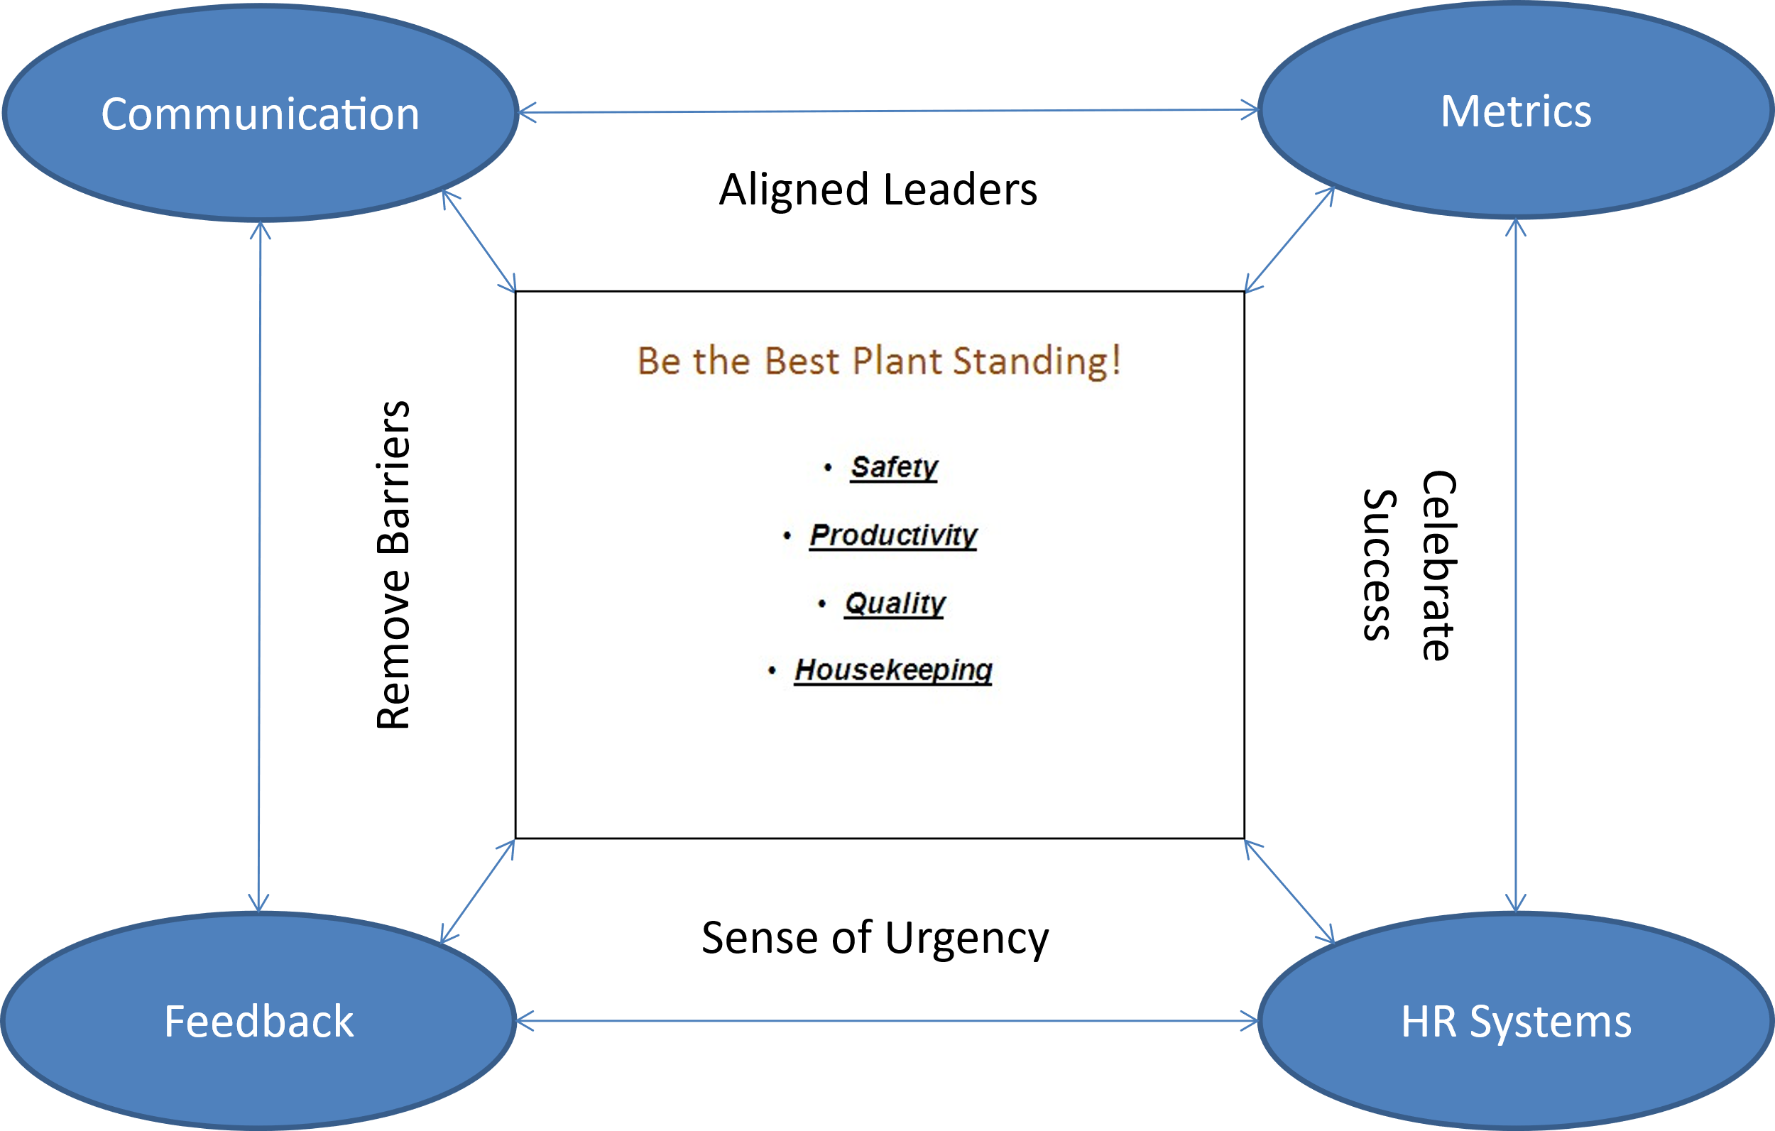

Chapter IX
Company Culture:
Balancing Organizational Performance and Employee Preferences
“In a world where everything else can be copied, your people and your culture are your only true sustainable competitive advantage.”
Marilyn Carlson Nelson - Co-Chair, Carlson Holdings

Watch what happens when you ask a group this question:

What is culture?

Uncomfortable giggles, averted gazes, and occasional looks of indignation follow. Sometimes the question comes back to you like a boomerang, and you get to experience the same tension.

To be fair, Edgar Schein isn’t convinced that culture should be defined: “’Culture’ is a messy and divergent concept […] it does not lend itself to clear definition and measurement.” But, expected workforce behavior is a good starting point. Behavior reflects the subconscious assumptions that employees accumulate over time.

Consider this exchange:
- Sara – “Why do we do record these defects?”
- Bill – “I don’t know. There must be a reason, though.”

In this context, the book treats culture as an enduring and commonly held set of assumptions, often subconscious, about appropriate behavior at work. Culture-inconsistent behavior is often extinguished; culture-consistent behavior is ignored or goes unnoticed.

This chapter expands on the options that executives have as they balance creating or maintaining a competitive edge via culture-consistent behavior.

Chapter X
Final Thoughts:
Build Momentum Flexibly
“Be stubborn on vision, but flexible on details.”
Jeff Bezos

While each of the previous chapters explores a component of the Strategy-to-Culture Value Chain, this chapter will reinforce the value of connecting them to company strategy and, by default, to each other. How they work together to create a competitive advantage is the focus of Chapter 10.

It will feature examples of alignment from the authors’ experiences and from the fictitious executive team starting up an adjacent business.

This chapter highlights the value of the fictitious executive team story line. Connecting people systems in the “real world” is often accomplished by incremental changes to a subset of existing processes to accommodate market and/or strategy changes. While this is a valuable perspective that we plan to share throughout the book, the story of the executives starting up an adjacent business allows for a more wholistic/integrated description of the people systems and the value they bring when they are connected.

This chapter will also introduce the dynamic nature of the Strategy-to-Culture Value Chain to accommodate market and/or strategy changes. This can be a result of the “Reshapes Environment” component of the value chain or an executive team’s decision to change the direction of their organization. This chapter makes the case for being intentional about predicting market changes, changing strategy accordingly, and assessing the extent to which changes in people systems should follow.

- Projected word count
We expect this book to be between 55,000 and 60,000 words

- Projected timetable
Our timeline is relatively short given that much of the book’s content is based on articles written and presentations delivered by the authors. We expect to complete the book three to four months after acceptance.

- Biographies
Foreword Options
William "Bill" Schultz, MBA (Atlanta, GA) - is a seasoned global executive with a track record of leading multi-billion-dollar organizations through complex transformations. He formerly served as President and CEO of Coca-Cola Refreshments Canada and held senior leadership roles at Georgia-Pacific, including President of Dixie – the disposable tableware business. A specialist in strategic configuration and scale, Bill currently is a Board Member at Freshii, Micromart, Vorto, and Black Sheep Coffee. As Principal of Pace Strategies, he provides high-level advisory to startup and growth-stage firms, bridging the gap between Fortune 500 strategy and agile execution.

Alexis A. Fink, PhD (Portland, OR) - Alexis is a preeminent technology executive and scholar who has defined the modern landscape of people analytics and workforce strategy. Her distinguished corporate career includes senior leadership roles at Microsoft, Intel, and BASF, most recently serving as Vice President of People Analytics and Workforce Strategy at Meta. A prolific author and thought leader, Dr. Fink has co-authored three foundational books and is a recognized authority on leveraging human capital data to drive enterprise-scale performance. Her expertise in configuring high-performance workforces within the world’s most complex digital ecosystems provides a critical bridge between data-driven strategy and global business execution. She is a former President and Fellow of the Society for Industrial and Organizational Psychology

David V. Day, PhD (Claremont, CA) - David is a world-renowned scholar and the Steven L. Cooley Chair in Ethical Leadership at Claremont McKenna College and Executive Director of the Kravis Leadership Institute. Widely regarded as the preeminent authority on the science of leadership development, Dr. Day has spent over three decades bridging the gap between rigorous psychological research and organizational impact.
As a prolific researcher, he has authored or edited several foundational volumes, including The Oxford Handbook of Leadership and Organizations, and has published more than 100 peer-reviewed articles in top-tier journals. He previously served as the Lead Editor of The Leadership Quarterly, the premier global outlet for leadership science. His work has been instrumental in shifting the corporate paradigm from "leader development" (individual skill-building) to "leadership development" (building collective organizational capacity). A Fellow of the Society for Industrial and Organizational Psychology (SIOP) and the American Psychological Association, Dr. Day’s insights are sought after by global institutions looking to architect sustainable, high-performance leadership cultures.

Authors
S. Richard Park, PhD
LinkedIn
Rick partners with executive business leaders to create a competitive advantage through people. He has held specialized roles in assessment design and validation, workforce development, rewards, performance management, culture, talent management, and organizational effectiveness.

Rick’s passion for business strategy prompted him to transition into HR Executive roles supporting CEOs and other executives with global responsibilities. He has held globally focused roles in technology (Dell, Microsoft), manufacturing (Georgia-Pacific, KSB SE & Co. KGaA, Sylvamo/International Paper), and HR consulting (AON).

Today Rick is Principal and CEO of Talent Alignment, LLC., a full-service HR consulting firm. He brings a practical approach to the firm’s clients by focusing on delivering a competitive advantage through people. His ability to speak to executive leaders in business terms is much appreciated by his partners and their clients.

Rick is featured in the #1 Best Seller When Work Works. One business owner/entrepreneur wrote - "Rick's approach to engaging employees in the battle for market share is easy to understand, practical, and well-researched."

His volunteer work involves coaching incarcerated individuals/groups and announcing high school sports.

Rick earned an undergraduate degree from Indiana University – Bloomington, a master’s degree from Illinois State University, and a PhD in Industrial/Organizational Psychology from The University of Akron to help prepare him for a career in HR, Talent Management, and OE.

Selected presentations/publications:
- The Journey from “Specialist” to “Strategic Business Partner”: A View from the Trenches
  - Workshop - 62nd Annual Indiana HR Conference
- Establishing a Competitive Advantage: Developing Leadership Capability to Deliver Strategy
  - Delivered to Executive Leaders at CJK Group
- Rethinking Recruiting, Selection, and Retention in a Tight Labor Market
  - Redmond, WA Chamber of Commerce
- Narrowing Down Candidate Pools: Navigating Employment Law and Assessment Practices
  - HR Executive Roundtable
  - SHRM – Lake Washington Symposium
- Leveraging the Strategy –> Performance –> Rewards Value Chain to Win Your Markets
  - Seattle SHRM
- Is Your Company Culture a Competitive Advantage?
  - Portland Area I/O Psychologists
  - Snohomish County HR Association
- Engaging a Workforce in Business Strategy
  - Washington State SHRM Conference Workshop
  - Michigan Association of I/O Psychology
- Emotional Intelligence v. Personality v. IQ - Does Emotional Intelligence Really Work?
  - SHRM-UW
- Diagnosing and Improving Executive Performance (Publication)
  - Florida SHRM
Tracy L. Platt, MS, GPHR, SPHR
LinkedIn
Tracy is a C-suite human capital executive and global board advisor with more than 25 years of experience designing and delivering transformative, data-driven strategies across Fortune 100 and 500 corporations. She currently serves as Chief Human Resources Officer at Newell Brands, partnering with the Board of Directors and the Compensation Committee. In this role, she has advanced large-scale operating model transformations, product innovation, and sustainable practices that enhance both business outcomes and employee engagement.

Recognized for creating innovative, high-performing cultures, Tracy has led organizations where leaders are accountable, talent thrives, and business strategies align with people strategies. A pioneer in digital HR, she has integrated analytics, AI, and workforce planning technologies to modernize HR functions and accelerate enterprise adaptability.

Her career includes leadership roles at Cerner, Medtronic, GE Healthcare, and Lands’ End. At Cerner, she prepared the company for its $30B acquisition by Oracle, while at Medtronic she drove organizational and cultural integration in the $43B Covidien merger. Her global experience spans the Americas, EMEA, and Asia Pacific.

Beyond the corporate arena, Tracy has contributed to civic and industry initiatives, from workforce development with the Chamber of Commerce to launching Cerner’s global philanthropic foundation. A published thought leader on leadership, workforce transformation, and the future of work, she has co-authored works with MIT and the World Economic Forum.
She holds a Master of Science in Industrial and Organizational Psychology along with advanced certifications in executive coaching, organization development, Lean Six Sigma, and ESG principles. Based in Atlanta, Georgia, she continues to serve in her role at Newell Brands.

Joseph M. Dunlap, MS
LinkedIn
Joe is a global learning and development leader with over 25 years of experience helping organizations improve workforce capability, leadership effectiveness, and performance across complex environments.

His work has focused on building practical systems for continuous learning, workforce development, leadership readiness, and performance improvement—always with an emphasis on connecting development to business strategy, real work, and measurable outcomes.
Joe has partnered with a diverse range of organizations, including NASA, Harley-Davidson, U.S. Air Force, Cornell University, National Oceanic and Atmospheric Administration (NOAA), and Molson Coors.

He currently leads the learning and development function for CJK Group, an international organization in the printing and electronic media industries with 24 sites worldwide.
Joe has been formally recognized by the states of Wisconsin, Kentucky, Ohio, New Hampshire, and Minnesota for advancing workforce capability. He is a contributor to HR and performance-focused publications such as the Leonardo Institute, RedThread Research, and the Skills Roundtable, and regularly appears on podcasts including Performance Matters, Talent Management Truths, and the ISPI Community of Practice.

He holds a bachelor’s degree from Northeastern University and a master’s degree in Organization, Workforce, and Leadership Studies from Texas State University.

APPENDIX A
Sample of Approachable and Engaging Writing Style
Draft content from Chapter II – Strategy Doesn’t Have to be Boring!

Imagine yourself walking into your first executive team meeting as the company’s first CFO. You’ve learned a lot about the finance and accounting function over the past week and your peers have done what they could to bring you up to speed on the business.

After warmly welcoming you to the team the CEO refers to the meeting’s agenda and says, “Let’s get started.”

Naturally, you feel like a deer in the headlights. Unprepared. Confused. Uncomfortable. Mayhem in a conference room.

Yet you’re still confident.

While there are many things you will learn over time (operational issues, products, company-specific terminology, etc.), some of these are central to the business’ future direction. These are the company’s preferred customers, mission, vision, and strategy.

Over time you’ll also learn how (or whether) these critical ideas support each other. Plus you’ll learn how to translate them for your finance and accounting team…the “secret sauce” in engaging them in the “why” they do the work they do.

APPENDIX B
Sample content introducing the current and adjacent businesses, the CEO, and the storyline that will help make subsequent content concrete. This box will appear at the end of Chapter I – Why Company Culture is a Potential Competitive Advantage.
Are We Ready?

You’re sitting in the owner’s office putting the finishing touches on the presentation she’ll deliver to investors tomorrow. As her HR manager, you’ve poured all you have into the business case to create an adjacent business for “Lauren’s Bagels and Bakery” chain of stores.

“We’re so good at selling fresh bagels directly to customers at our 12 stores, but putting six of them in a paper bag and getting them to the deli counter at grocery stores isn’t even remotely close to selling at our stores!” you say.

“It really isn’t,” says Lauren. “We’re not used to running a factory to pump out bagels, not to mention putting them into paper bags. The citizens of Kansas know us though, which is a plus.”
“It’s true. Plus, the grocery store delis are eager to give us a shot,” you say.

“I’ve had some high-level conversations with some of the investors, but they’re pretty tight-lipped about their support. However it ends up, I will always think that offering Lauren’s Bagels in a paper bag at the deli counter is worth pursuing,” says Lauren.

“Me too. I’d be surprised if the investors ask you something we haven’t thought about. We’ll see where it goes,” you say.

Lauren responds. “I agree! It wasn’t easy, but our executive team really came together to make a compelling business case. Keep your fingers crossed that our investors agree.”

“They’re already crossed,” you reply. “See you at the hotel conference center tomorrow!”

